Kennesaw State University
Department of Computer Science
College of Science and Mathematics

CS 4720 Section 01 Introduction to Computational Science - Fall 2014

Assignment No. 4
-------------------------------------------------
"Determining the Mathematical Model to Represent Given Data"

Richard Godbee
rgodbee1@students.kennesaw.edu

September 18, 2014

Initial Problem Statement:

In a typical spring day, the temperature varies according to the data recorded in Table 1. Develop a C program to compute first differences, second differences, and the factors. Formulate the difference equations and functional equations for the temperature. What type of growth does the model exhibit? Is this discrete or continuous data? Discuss. Plot the relevant data with Gnuplot.

Develop a C program to compute first and second differences. Produce line chart of the data list in Number of Patients for year 1995-2002 table below. Discuss how the number of patients changes in a specified period.

Summary and Purpose of the Assignment Activity:

Temperature Values over a 12-hour Period
The main problem for assignment 4 is to determine what mathematical model should be used when comparing and estimating the given data. The first problem had several different test that needed to be done to gain a better understanding of the data. Through checking the first and second difference the data did not seem to follow a linear or quadratic path. Checking the factor of the data did yield a nearly constant factor, which translates in to a geometric model. The temperature can be estimated with Sn+1 = C Sn, where C is 1.32. The differences were found using the diff(s,n), where s is the data set, and n is the length of the data set. The factor was found by using factor(s,n), where s is the data set, and n is the length of the data set. The basic_lib libray was used in these computations. The compile code is as follows:
gcc -Wall -o temperature temperature.c basic_lib.o -lm

Number of Patients for year 1995-2002
The number of patients from 1995 to 2002 has increased, but at what rate? Through the use of finding the first and second differences between the given data, the model that best estimates the growth rate of the patients is a quadratic model. This can be shown by the second difference being a constant value. The graph on page 4 illustrates this. The differences were found using the diff(s,n), where s is the data set, and n is the length of the data set. The compile code is as follows:
gcc -Wall -o patients patients.c basic_lib.o -lm

Data Table:

Temperature Values over a 12-hour Period
Time | 7 | 8 | 9 | 10 | 11 | 12 | 1 | 2 | 3 | 4 | 5 | 6
Temp (F) | 51 | 56 | 60 | 65 | 73 | 78 | 85 | 86 | 84 | 81 | 80 | 70
Difference 1 |  | 5 | 4 | 5 | 8 | 5 | 7 | 1 | -2 | -3 | -1 | -10
Difference 2 |  |  | -1 | 1 | 3 | -3 | 2 | -6 | -3 | -1 | 2 | -9
Factor |  | 1.1 | 1.07 | 1.08 | 1.12 | 1.07 | 1.09 | 1.01 | 0.98 | 0.96 | 0.99 | 0.88
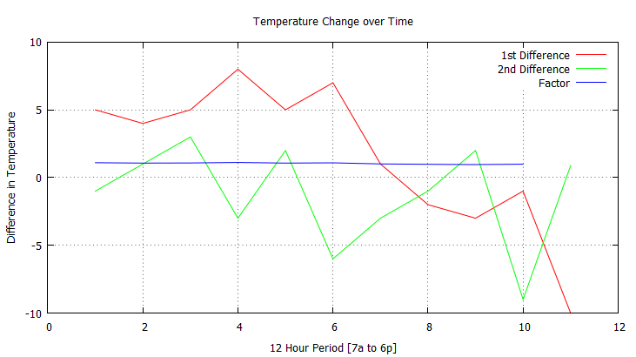

Number of Patients for year 1995-2002
Year | 1995 | 1996 | 1997 | 1998 | 1999 | 2000 | 2001 | 2002
Initial data | 5500 | 8500 | 13500 | 20500 | 29500 | 40500 | 53500 | 68500
First Difference |  | 3000 | 5000 | 7000 | 9000 | 11000 | 13000 | 15000
Second Difference |  |  | 2000 | 2000 | 2000 | 2000 | 2000 | 2000

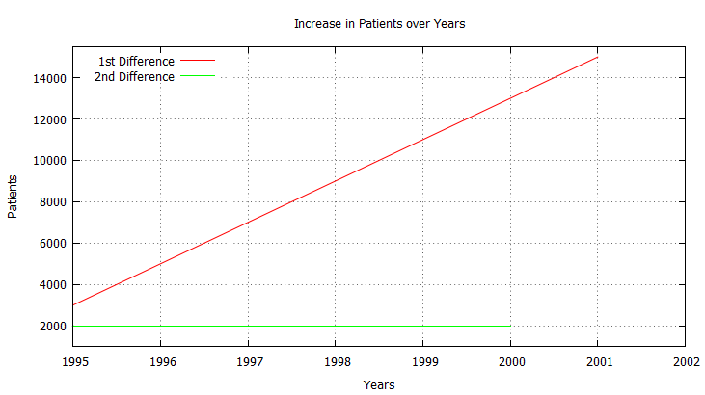
Source Code:

Temperature Computation
/*
Program: temperature.c
*/
#include <stdio.h>
#include <stdlib.h>
#include <math.h>
#include "basic_lib.h"

int main()
{
const int timePeriod = 12;

double temperArray[] = {51, 56, 60, 65, 73, 78, 85, 86, 84, 81, 80, 70};
double *d; //first differences
double *d2; //second differences
double *f; //factors
int i;
// initial data
printf("Initial data given.\n");
for(i = 0; i < timePeriod; i++)
printf("%.2f\t", temperArray[i]);

printf("\nFirst Difference of the given data.\n");
d = diff(temperArray, timePeriod);
// spacing fr formatting
printf("\t");
// print first difference array
for(i = 0; i < timePeriod-1; i++)
printf("%.2f\t", d[i]);

printf("\nSecond Difference of the given data.\n");
d2 = diff(d, timePeriod-1);
// spacing fr formatting
printf("\t\t");
// print second difference array
for(i = 0; i < timePeriod-2; i++)
printf("%.2f\t", d2[i]);

printf("\nFactors of the given data.\n");
f = factor(temperArray, timePeriod);
// spacing fr formatting
printf("\t");
for(i = 0; i < timePeriod-1; i++)
printf("%.2f\t", f[i]);

printf("\n");

return 0;
}

Patients Increase over Years
/*
Program: temperature.c
*/
#include <stdio.h>
#include <stdlib.h>
#include <math.h>
#include "basic_lib.h"

int main()
{
const int years = 8;
int startYear = 1995;

// data from table 13.1 Number of patients for years 1995–2002. page 176
double patients[] = {5500, 8500, 13500, 20500, 29500, 40500, 53500, 68500};
double *d; //first differences
double *d2; //second differences
int i;
for(i = 0; i < years; i++)
{
printf("%d\t", startYear);
startYear++;
}
// initial data
printf("\nInitial data given.\n");
for(i = 0; i < years; i++)
printf("%.0f\t", patients[i]);

printf("\nFirst Difference of the given data.\n");
d = diff(patients, years);
// spacing fr formatting
printf("\t");
// print first difference array
for(i = 0; i < years-1; i++)
printf("%.0f\t", d[i]);

printf("\nSecond Difference of the given data.\n");
d2 = diff(d, years-1);
// spacing fr formatting
printf("\t\t");
// print second difference array
for(i = 0; i < years-2; i++)
printf("%.0f\t", d2[i]);

printf("\n");

return 0;
}

Comments and Conclusion:
Working on these different problems showed different methods for interacting with arrays and structures. The linked list shows a flexible way from implementing an array.

Assignment Questions:
1) In a typical spring day, the temperature varies according to the data recorded in Table 1. Develop a C program to compute first differences, second differences, and the factors. Formulate the difference equations and functional equations for the temperature. What type of growth does the model exhibit? Is this discrete or continuous data? Discuss.Plot the relevant data with Gnuplot.
The implementation of the C code is shown above. The values used in the calculations are shown on page 3. The program is used to perform operations on complex number arrays using both arrays and structs.

- Develop a C program to compute first and second differences. Produce line chart of the data list in Number of Patients for year 1995-2002 table below. Discuss how the number of patients changes in a specified period.

The implementation of the C code is shown above. The values used in the calculations are on page 3. The program uses linked lists. The program was used to estimate the model best suited to mimic the given data.

References:

Garrido, J. M., 2014, Introduction to Computational Modeling using C and Open-source Tools, CRC Press/Taylor & Francis Group, Boca Raton, FL.

